Rural+ Better opportunities through ability growth

European project to help people from rural areas

On the 27th of November 2019, in Calarasi, Romania, Rural+ Project had the first kick off meeting.
The coordinator of the project Calarasi County Branch of the Romanian Commune Association hosted representatives of organizations coming from Portugal (Previform), Italy (Polygonal), Cyprus (Stando), Romania (MSM).

The project is funded by Erasmus +, the program of European Commission promoting the development of education in Europe, and is focused on training people from rural areas to get the skills and competences needed for the labour market.

The project will last two years and in this first phase will explore training competencies needed for the target groups and collect opinions from experts in training and labour market.
Then the project will create an e-learning platform and learning materials in the themes:
- Business etiquette
- Learning-to-learn
- Professional Digital Literacy

2 Training events will take place during the project, one in 2020 in Cyprus, and the other one the 2021 in Portugal, each with a duration of 5 days.
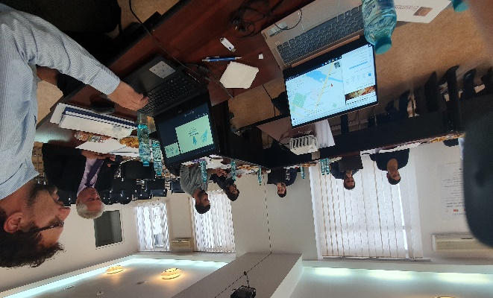
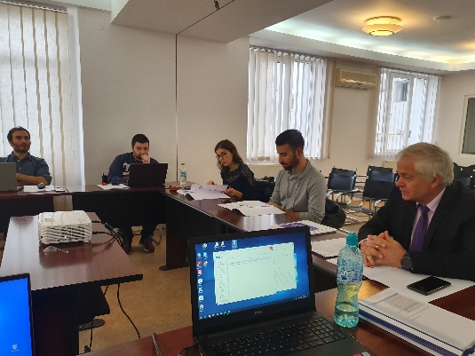

For more info

Rural+

